William M. Schaadt
August 15, 1940 – June 1, 2013

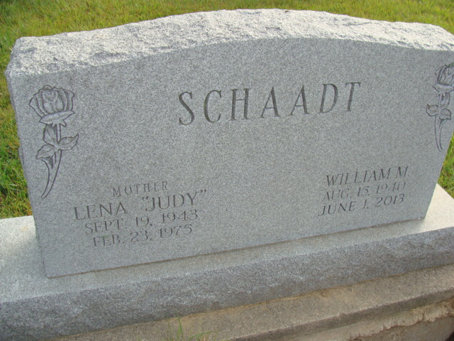
Photo by Alicia Kneuss

William M. "Bill" Schaadt, 72, Chattanooga, OH passed away on Saturday June 1, 2013 at his home. He was born to Victor and Luella Schaadt on August 15, 1940 in Mercer County, OH. He married Judy Ousley on September 23, 1964 in Berne, IN who is deceased. He later married LaDonna McCullough Case on April 213, 1977 who survives.
Bill retired from International Harvester in 2000 and worked for Berne Furniture for an additional 7 years. He also served in the National Guard. And enjoyed farming throughout his life. He was baptized in the Bethel Brethren Church in Berne and presently attending The Bridge Church in Decatur.
Survivors include his wife, LaDonna, daughter, Tracy (David) O'Dell of Columbus, IN, stepson, Eric (Sunni) Case, Eaton, IN, brothers; Ralph (Cathy) Schaadt of Bluffton, John (Cathy) Schaadt of Decatur, 6 grandchildren, and numerous nephews and nieces.

Yager-Kirchhofer Funeral Home, Adams County, Indiana
June 1, 2013

