Victor Andrew Schaadt
November 15, 1906 – November 30, 1980

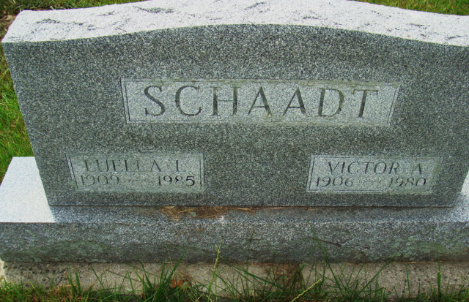
Photo by Alicia Kneuss

Indiana, U.S., Death Certificates, 1899-2017
Name Victor A. Schaadt
Gender Male
Race White
Marital Status Married
Age 74
Birth Date 15 Nov 1906
Birth Place Ohio
Death Date 30 Nov 1980
Death Place Decatur, Adams, Indiana, USA
Death Registration Date 1980
Father William Schaadt
Mother Rosa Fickert
Spouse Luella Schaadt, informant
Burial MRE Cemetery 12/3/1980

