Tommy D. Schaadt
August 18, 1930 – October 20, 1981

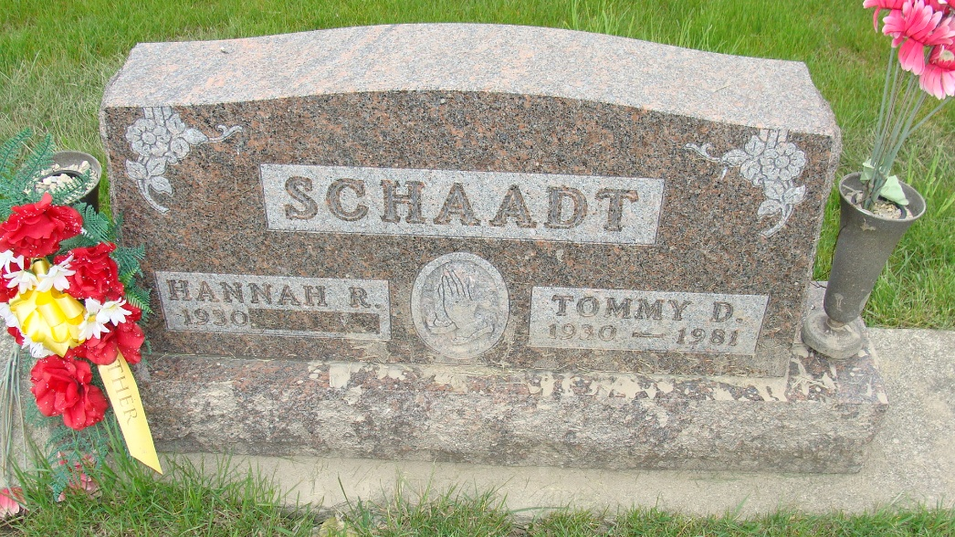
Photo by Alicia Kneuss

Indiana, U.S., Death Certificates, 1899-2017
Name Tommy D. Schaadt
Gender Male
Race White
Marital Status Married
Age 51
Birth Date 18 Aug 1930
Birth Place Ohio
Death Date 20 Oct 1981
Death Place Fort Wayne, Allen, Indiana, USA
Death Registration Date 1981
Father Henry Schaadt
Mother Edna Dailey
Spouse Hannah Habegger Schaadt, informant
Burial MRE Cemetery 10-23-1981

