Luella Leona (Affolder) Schaadt
May 12, 1909 – May 12, 1985

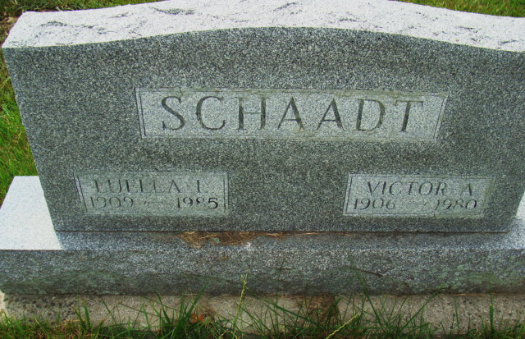
Photo by Alicia Kneuss

Indiana, Birth Certificates, 1907-1940

Name Leuella Leona Affolder
Gender Female
Birth Date 12 May 1909
Birth Place Wabash, Adams, Indiana, USA
Father Martin Affolder
Mother Zella Goff
Certificate Number 220
Roll number 45385_358755
Volume Range 142 – 146
**

Ohio, U.S., County Marriage Records, 1774-1993

Name Luella Affolder
Gender Female
Marriage Age 19
Birth Date abt 1909
Marriage Date 8 Dec 1928
Marriage Place Mercer, Ohio, USA
Father Martin Affolder
Mother Mary Lustner
Spouse Victor A Schaadt
Film Number 002366955

