Hannah Ruth (Habegger) Schaadt
July 17, 1930 -

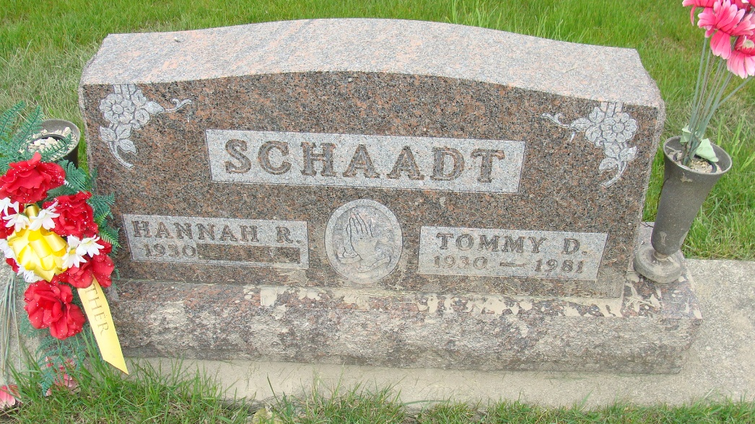
Photo by Alicia Kneuss

Indiana, U.S., Marriages, 1810-2001
Name Hannah Ruth Habegger
Gender Female
Race White
Age 20
Event Type Marriage Registration (Marriage)
Birth Date 17 Jul 1930
Birth Place Adams, Indiana
Marriage Date 19 Aug 1950
Marriage Place Indiana, United States
Residence Place Decatur, Indiana
Father Edgar Habegger
Mother Savilla Roth
Spouse Tommy David Schaadt
Officiator Edward F Jaberg
Page 243

