Edna W. (Dailey) Schaadt
December 14, 1907 – July 17, 1986

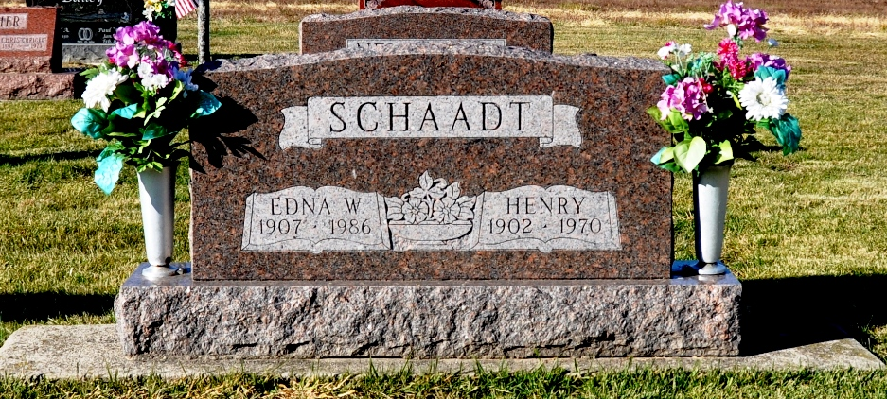
Photo by Deb Curry

Indiana, U.S., Death Certificates, 1899-2017

Name Edna Schaadt
[Edna Daily]
Gender Female
Race White
Marital Status Widowed
Age 78
Birth Date 14 Dec 1907
Birth Place Indiana
Death Date 17 Jul 1986
Death Place Berne, Adams, Indiana, USA
Death Registration Date 1986
Father David Daily
Mother Jane Trippy
Informant Phyllis Paul, daughter
Burial M.R.E. 7/20/1986

