Karl Scare
August 13, 1904 – May 20, 1989

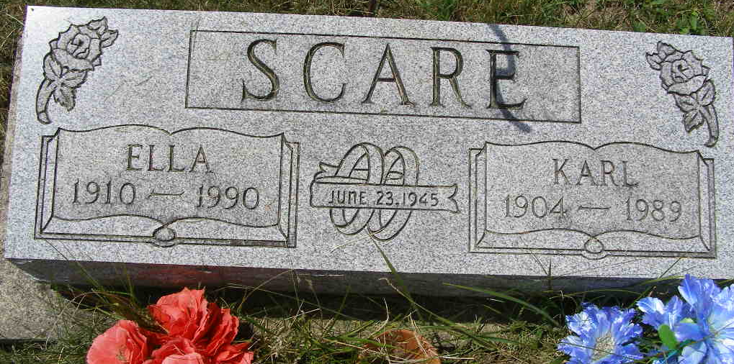
Photo by Shaunda Bedwell Opdycke

Indiana, U.S., Death Certificates, 1899-2017

Name Karl Scare
Gender Male
Race White
Marital Status Married
Age 84
Birth Date 14 Aug 1904
Birth Place Convoy, Ohio
Death Date 20 May 1989
Death Place Decatur, Adams, Indiana, USA
Death Registration Date 1989
Father Peter Scare
Mother Hannah Scare
Spouse Ella Gerber Scare, informant
Burial 5/23/1989 M.R.E.

