Ella (Gerber) Scare
December 30, 1910 – December 30, 1990

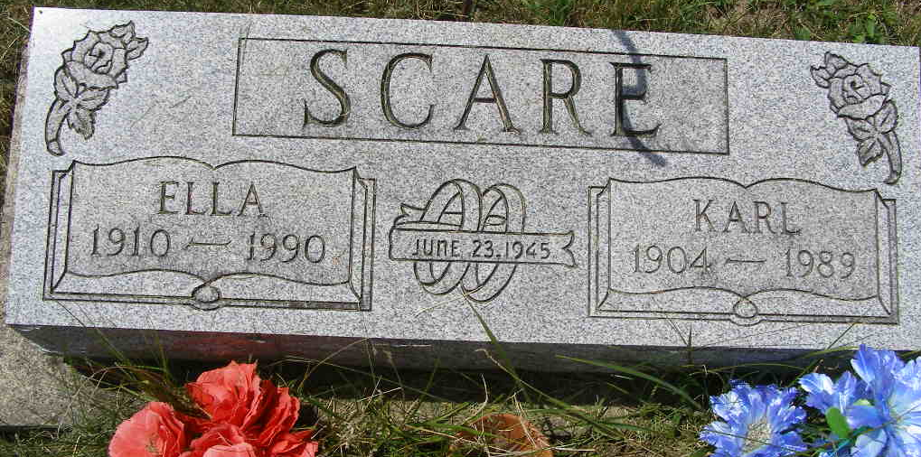
Photo by Shaunda Bedwell Opdycke

Indiana, U.S., Death Certificates, 1899-2017

Name Ella Scare
[Ella Gerber]
Gender Female
Race White
Marital Status Widowed
Age 80
Birth Date 10 Dec 1910
Birth Place Adams County, Indiana
Death Date 30 Dec 1990
Death Place Berne, Adams, Indiana, USA
Death Registration Date 1990
Father Robert Gerber
Mother Louise Mathys
Informant Jerry Flueckiger, son
Burial 1/2/1991 M.R.E.

