Mary (Tschandre) Saurer
November 1836 – February 4, 1905

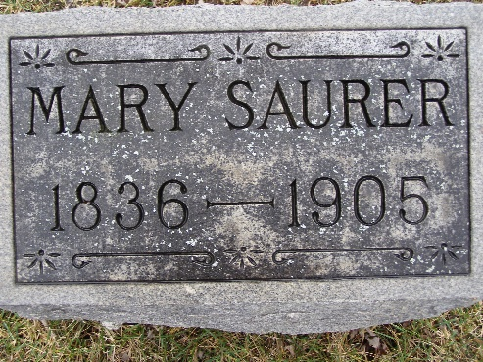
Photo by Shaunda Bedwell Opdycke

Indiana Deaths, 1882-1920

Name Mary Ann Saurer
Date Feb 04, 1905
Location Berne
Age 69 Yr
Gender Female
Race White
Source location County Health Office, Decatur
Source notes The source of this record is the book H-20 on page 6 within the series produced by the Indiana Works Progress Administration.
**

2005 Adams County (IN) Death Index

Last name Saurer
First name Mary Ann
Sex F
Age 69
Death date 2/4/1905
Death place Berne
Book H-20; Page 6

