John Saurer
January 31, 1826 – January 8, 1912

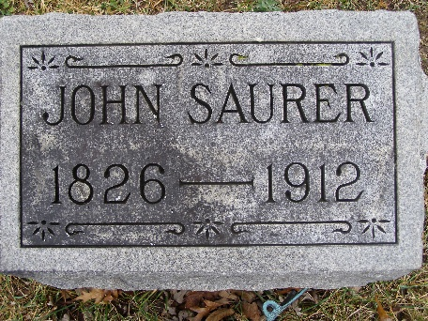
Photo by Shaunda Bedwell Opdycke
Biery-Yager Funeral Home Record, Adams County, Indiana
John Sower; Died at Berne; date not stated; Funeral home record dated January 10, 1912; Age 85 years, 11 months, 8 days; Funeral January 10, 1912 at Reformed Church; Burial at MRE Cemetery, Lot or Grave # 6; Charge to Fred Shafer; Order given by Fred Shafer
**

Indiana, U.S., Death Certificates, 1899-2017

Name John Saurer
Gender Male
Race White
Marital Status Widowed
Age 85y 11m 7d
Birth Date 31 Jan 1826
Birth Place Switzerland
Death Date 8 Jan 1912
Death Place Berne, Adams, Indiana, USA
Death Registration Date 1912
Father Christian Saurer b. Switzerland
Mother --- Tsantry b. Switzerland
Spouse Mary Ann b. Switzerland
Informant Fred Shafer
Burial MRE 1/10/1912
**

Jean (aka John or Johann) C. Saurer from tree Martz/Landry Family Tree

Birth 31 Jan 1826 Renan, Bern, Switzerland
Marriage 13 Dec 1855 Vera Cruz, Wells, Indiana, USA
Residence 1910 Monroe City, Adams, Indiana, USA
Death 8 Jan 1912 Berne, Adams, Indiana, USA
Father P. Christian Saurer (1783-1868)
Mother Susanna Seigrist (1797-1869)
Spouse Marie Elizabeth Anna Tschantre (1836-1905)
7457 People 14 Records 27 Sources

