Wayne E. Sauers
November 7, 1924 – April 22, 2019

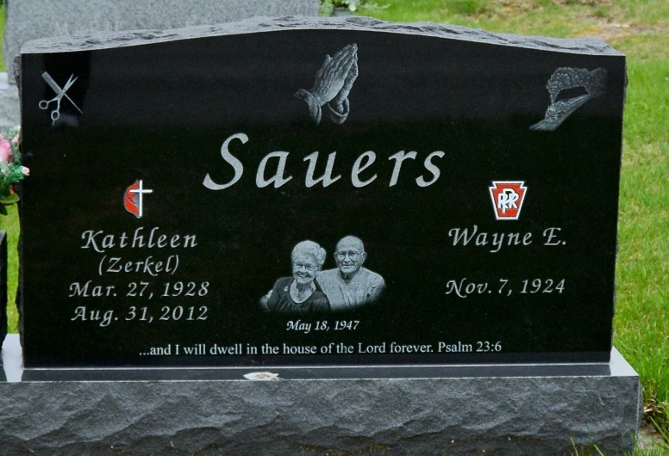
Photo by Deb Curry
Wayne E. Sauers, age 94, passed away Monday morning April 22, 2019 at River Terrace Estates, in Bluffton. Wayne was born in Fort Wayne, IN on Nov. 7, 1924, to Bert E. and Jennie M. (Genaro) Sauers. He married Olive Kathleen (Zerkel) on May 18, 1947; she preceded him in death on Aug. 31, 2012.
In the 1930’s, Wayne and his family performed in the “Sauer Family Acrobat Act”, traveling to many local festivals. Wayne was a Train Conductor/Brakeman for 43 years with the Pennsylvania Railroad, retiring in 1985. He also served his country in the United States Army. Wayne was a member of the R/R Retirement Club and Lifelong member of the National Brotherhood of Railroad Trainman. After retirement Wayne enjoyed woodworking, making jewelry and collecting R/R memorabilia.
Wayne is survived by two sons, Michael Sauers of Ft. Wayne and Mark (Laurissa) Sauers of Bluffton; two daughters, Patty Sikora and Jennie (Tony) Williams, both of Ft. Wayne; along with seventeen grandchildren, 21 great grandchildren, and one great great grandchild; and a son-in-law, Mark Wheaton of Ft. Wayne.
In addition to his wife and parents, Wayne was preceded in death by a daughter, Linda Wheaton, in 2017; two sisters, Jeanette Renn and Doris Coddens; two brothers, Robert and Edward Sauers.
Visitation will be from 3:00 PM until 8:00 PM, on Wednesday, April 24, 2019, at Goodwin – Cale & Harnish Memorial Chapel in Bluffton, IN. Services will be held Thursday, April 25, at 10:30 AM, at the funeral home, with one hour of visitation prior to the service. Pastor Clark Stoller will officiate the service. Burial will take place at the MRE Cemetery in Berne, IN
Memorial contributions may be made to Friends Who Care Cancer Relief Foundation.

Goodwin – Cale & Harnish Memorial Chapel, Wells County, Indiana
April 22, 2019

