O. Kathleen (Zerkel) Sauers
March 27, 1928 – August 31, 2012

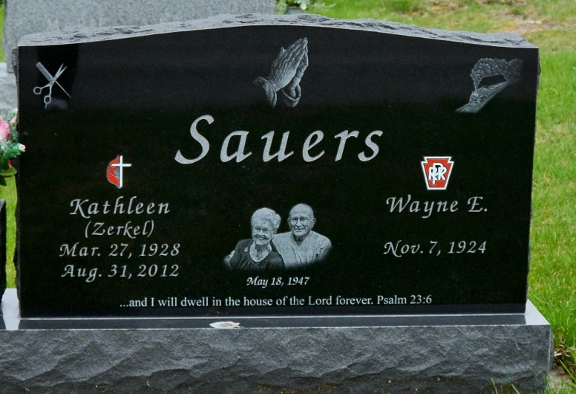
Photo by Deb Curry
O. Kathleen (Zerkel) Sauers, 84, Decatur, passed away August 31, 2012 in Ft. Wayne. She was born to Oliver K. and Marie (Burdg) Zerkel on March 27, 1928 in Decatur, Indiana. She married Wayne E. Sauers on May 18, 1947 who survives.
She was a member of the Living Water Church where she was very active being a Sunday School Teacher, Youth Leader, and served on various committees. Kate was a hairdresser for 30 years in Bluffton, IN. Special interests were sewing, and gardening. There were many roles that Kate played in life. A devoted mother, a beloved family member, gracious neighbor and friend, co-worker and parishioner, but most of all-Kate was (and still is) a beloved child of God.
Survivors include: two sons, Michael (Kathy) Sauers of Churubusco, Mark (Laurissa) Sauers of Bluffton, three daughters, Linda (Mark) Wheaton of Fort Wayne, Patty SiKora of Fort Wayne, and Jennie (Tony) Williams of Fort Wayne, brothers: Gene (Joyce) Zerkel of Anchorage, Alaska, James (Bev) Zerkle of Webb City, Missouri, Jerry (Sue) Zerkel of Longview, Texas, and Ronald (Sharon) Zerkel of Fort Myers, Fla. and a sister, Sherryl (Larry) Martin of Logansport,IN, 15 grandchildren and 13 great- grandchildren.
Preceding in death are her parents.
Funeral services are Wednesday, September 5, 2012 at 10:30 am at Yager-Kirchhofer Funeral Home with visitation one hour prior to services. Visitation also Tuesday from 2-5 and 6-8 pm. Officiating is Pastor Clark Stoller and Pastor Steven McPeek. Burial at the MRE Cemetery in Berne.
Preferred memorials are to the Visiting Nurse & Home Hospice &/or the Cancer Services of NE Indiana.

Yager-Kirchhofer Funeral Home
September 1, 2012

