Philip Sauders
December 14, 1873 – October 26, 1916

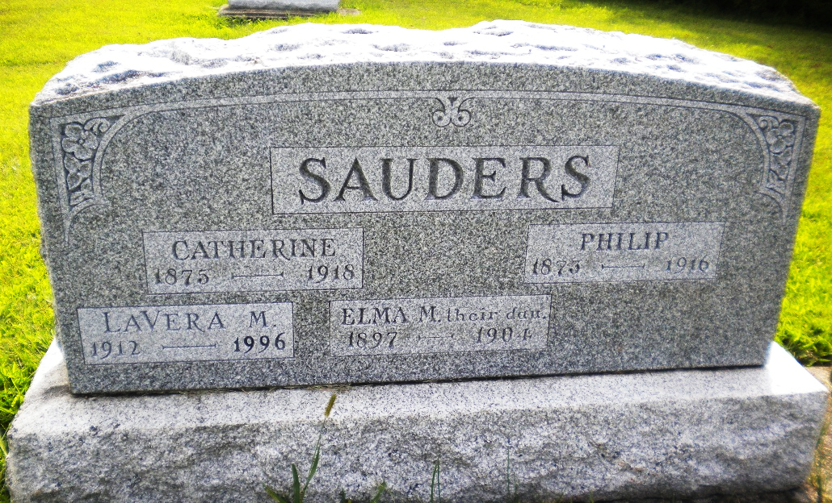
Photo by DSON1492

Indiana, U.S., Death Certificates, 1899-2017

Name Philip Sauder
Gender Male
Race White
Marital Status Married
Age 42y 10m 12d
Birth Date 14 Dec 1873
Birth Place Indiana
Death Date 26 Oct 1916
Death Place Fort Wayne, Allen, Indiana, USA
Death Registration Date 1916
Father Christian Sauder
Mother Barbra Witwer
Spouse Catherine Gunder Sauder, informant
Burial M.R.E. 10/28/1916
**

Biery-Yager Funeral Home Record, Adams County, Indiana

Philip Souder; Died October 26, 1916 at Lutheran Hospital from gall stones; Age 42 years; Salesman; Married; Religion: Evan.; Funeral October 29, 1916 at Evangelical Church; Burial MRE Cem.; Charge to Mrs. Souder; Order given by Mrs. Souder

