LaVera M. Sauders
January 19, 1912 – April 24, 1996

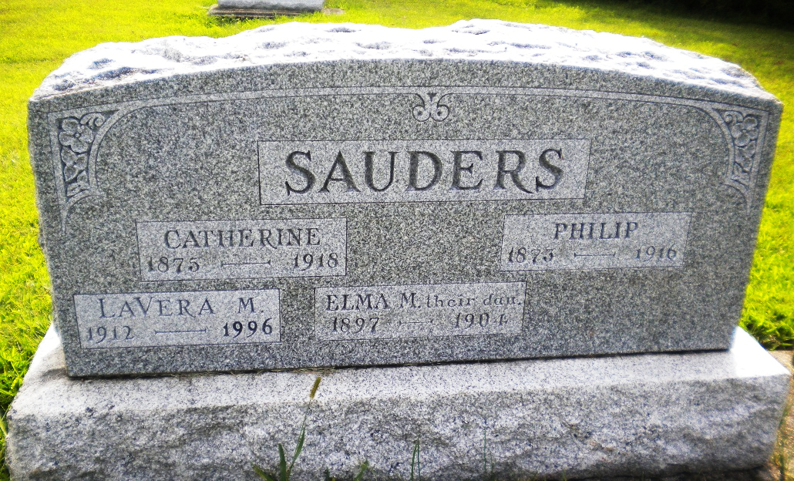
Photo by DSON1492

Indiana, U.S., Death Certificates, 1899-2017

Name Lavera M Sauder
Gender Female
Race Caucasian (White)
Marital Status Never Married (Single)
Age 84
Birth Date 19 Jan 1912
Birth Place Berne, Indiana
Death Date 24 Apr 1996
Death Place Fort Wayne, Allen, Indiana, USA
Death Registration Date 1996
Father Philip Sauder
Mother Catherine Luginbill
Informant Willodean Durfey, Niece
Burial MRE Cemetery 4/30/1996

