Elm Mae Sauders
December 14, 1897 – May 2, 1904

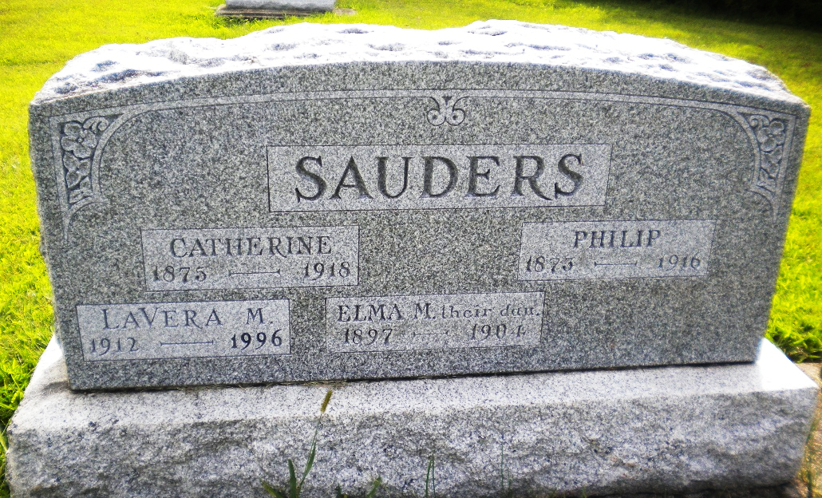
Photo by DSON1492

Indiana, U.S., Death Certificates, 1899-2017

Name Elma Mae Souders
Gender Female
Race White
Age 6y 4m 18d
Birth Date 14 Dec 1897
Birth Place Berne Indiana
Death Date 2 May 1904
Death Place Berne, Adams, Indiana, USA
Death Registration Date 1904
Father Philipp Souder, informant
Mother Katie Luginbill
Burial MRE Cemetery 5/4/1904

