Catherine ‘Katie’ (Luginbill) Sauders
March 20, 1875 – April 25, 1918

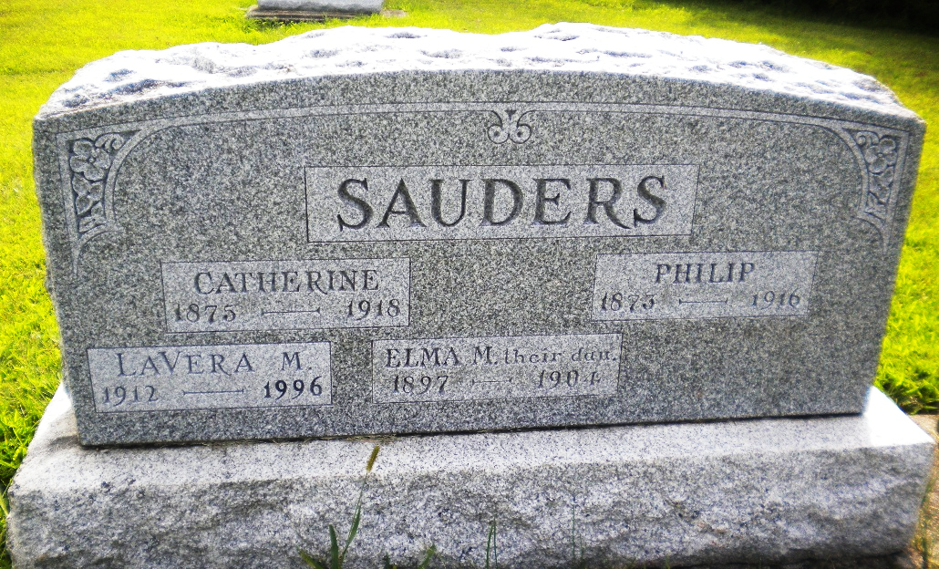
Photo by DSON1492

Indiana, U.S., Marriage Certificates, 1960-2012

Name Katie Luginbill
Gender Female
Marriage License Date 11 Oct 1895
Marriage Date 15 Oct 1895
Marriage Place Adams, Indiana, USA
Spouse Philip Sauder
**

Katharina Luginbill from tree 6eggroll.GED

Birth 20 Mar 1875 Adams, Indiana, USA
Marriage 15 Oct 1895
Death 25 Apr 1918
Father Christian Luginbill (1849-1926)
Mother Marianna Moser (1843-1917)
Spouse Philip Sauder (1873-1916)
106540 People 0 Records 0 Sources

