Safara Christian Sauder
September 12, 1896 – September 19, 1965

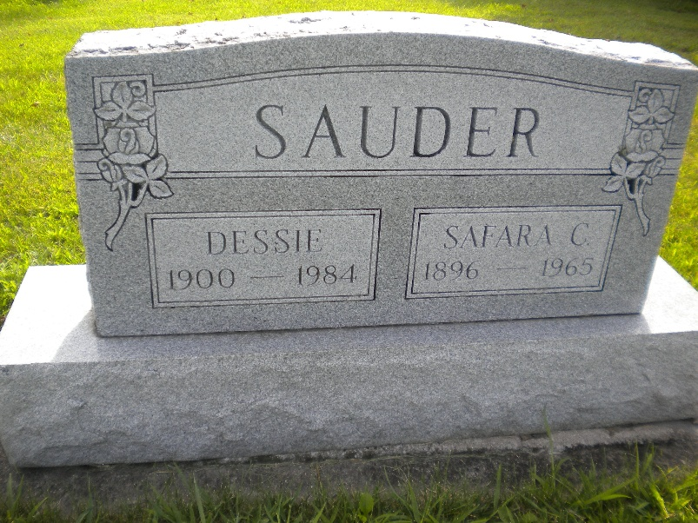
Photo by DSON1492

Indiana, U.S., Death Certificates, 1899-2017

Name Safare Christian Sauders
Gender Male
Race White
Marital Status Married
Age 69
Birth Date 12 Sep 1896
Birth Place Berne, Indiana
Death Date 19 Sep 1965
Death Place New Haven, Allen, Indiana, USA
Death Registration Date 1965
Father Phillip Saunders
Mother Katherine Luginbill
Informant Mrs. Katherine Liechty, daughter
Burial 9/22/1965 MRE Cemetery

