Julie Ann Sauder
October 19, 1958 – November 13, 1984

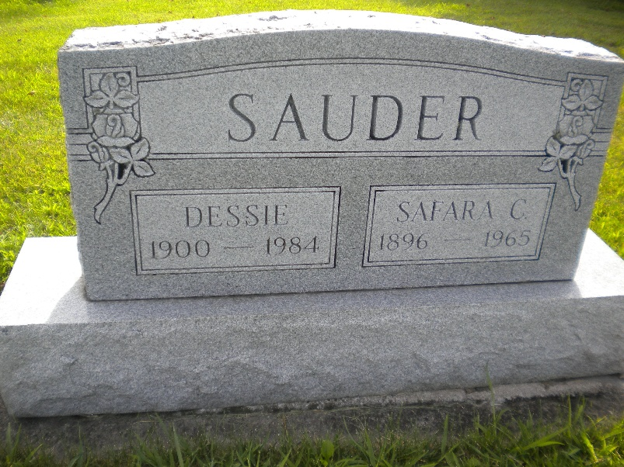
Photo by DSON1492

Indiana, U.S., Death Certificates, 1899-2017

Name Julie Ann Sauder
Gender Female
Race White
Marital Status Divorced
Age 26
Birth Date 19 Oct 1958
Birth Place Indiana
Death Date 13 Nov 1984
Death Place Geneva, Adams, Indiana, USA
Death Registration Date 1984
Father Robert Sauder, informant
Mother Juanita Rhodes
Burial MRE Cemetery 11/16/1984

