Dessie Gladys (Parr) Sauder
June 5, 1900 – June 29, 1984

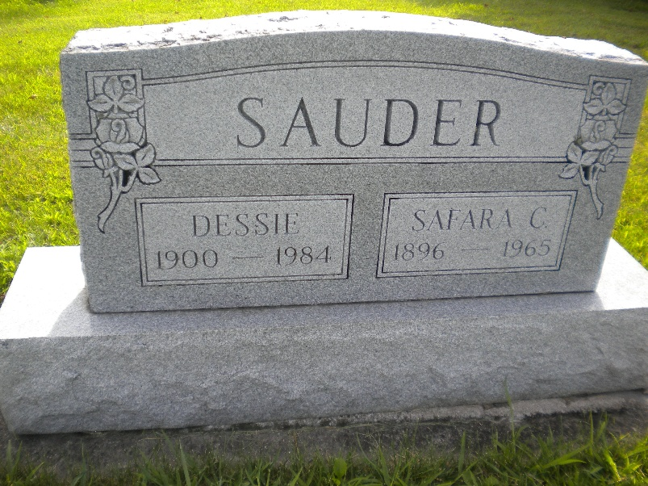
Photo by DSON1492

Indiana, U.S., Death Certificates, 1899-2017

Name Dessie Sauders (indexed as Sanders)
[Dessie Parr]
Gender Female
Race White
Marital Status Divorced
Age 84
Birth Date 5 Jun 1900
Birth Place Indiana
Death Date 29 Jun 1984
Death Place Portland, Jay, Indiana, USA
Death Registration Date 1984
Father Bertrum Parr
Mother Rosetta Cottrell
Spouse Safara C. Sauders
Informant Robert D. Sauders
Burial M.R.E. 7/2/1984

