Lillie Sylvia (Brunner) Sapp
December 24, 1902 – June 7, 1956

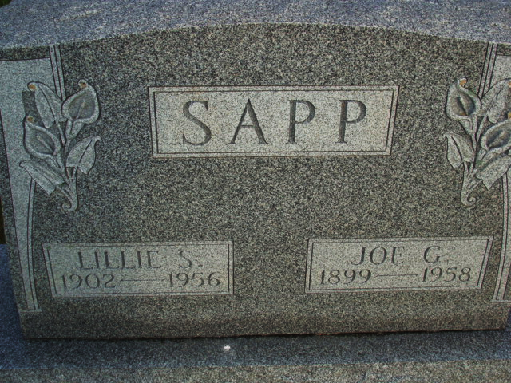
Photo by Alicia Kneuss

Indiana, U.S., Marriages, 1810-2001

Name Lillie Brumner
Gender Female
Race White
Age 21
Birth Date 24 Dec 1902
Birth Place Monroe Twp, Indiana
Marriage Date 29 Sep 1923
Marriage Place Indiana, United States
Residence Place Monroe Twp, Indiana
Father Lewis Brumner
Mother Anna Musser
Spouse Joe Sapp
Page 120
FHL Film Number 002321631
**

Ohio, U.S., Rutherford B. Hayes Presidential Center Obituary Index, 1810s-2016

Name Mrs Lillie (Lille) Sapp
Death Age 53
Birth Date abt 1903
Death Date Jun 1956
Death Place Ohio, USA
Spouse Joe Sapp
Newspaper Information Newspaper: Van Wert Times Bulletin, Newspaper Date: 18 Jun 1956, Newspaper Page: 2 Column: ; Repository: Brumback Public Library (Van Wert, Ohio); Years Available:| Newspaper: Wilshire Herald, Newspaper Date: 21 Jun 1956, Newspaper Page: 1 Column: ; Repository: Brumback Public Library (Van Wert, Ohio)

