Joseph George Sapp
December 26, 1890 – August 28, 1953

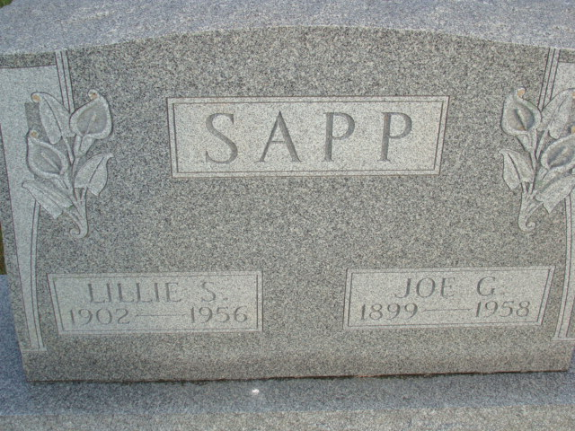
Photo by Alicia Kneuss

Indiana, U.S., Death Certificates, 1899-2017

Name Joe Sapp
Gender Male
Race White
Marital Status Widowed
Age 59
Birth Date 14 Feb 1899
Birth Place Indiana
Death Date 26 Jul 1958
Death Place Decatur, Adams, Indiana, USA
Death Registration Date 1958
Father Owen Sapp
Mother not listed
Informant Mrs. Paul Sowards, daughter
Burial 7/29/1958 M.R.E. Cemetery

