Joseph H. Sallot
December 26, 1890 – August 28, 1953

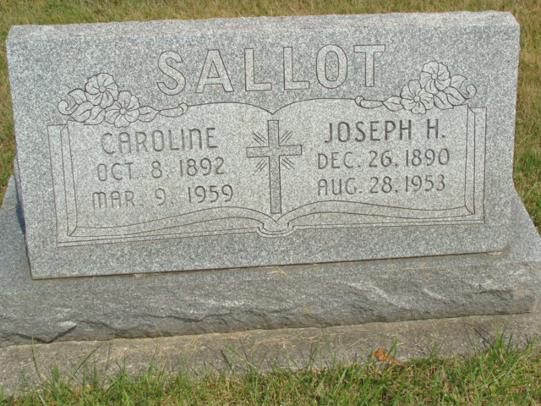
Photo by Alicia Kneuss

Indiana, U.S., Death Certificates, 1899-2017

Name Joseph Sallot
Gender Male
Race White
Marital Status married
Age 62
Birth Date 26 Dec 1890
Birth Place Fort Wayne, Indiana
Death Date 28 Aug 1953
Death Place Fort Wayne, Allen, Indiana, USA
Death Registration Date 1953
Father Victor Sallot
Mother Agatha Rayes
Informant Mrs. Caroline Sallot
Burial M.R.E. 9/1/1953

