Caroline E. (Beer) Sallot
October 8, 1892 – March 9, 1959

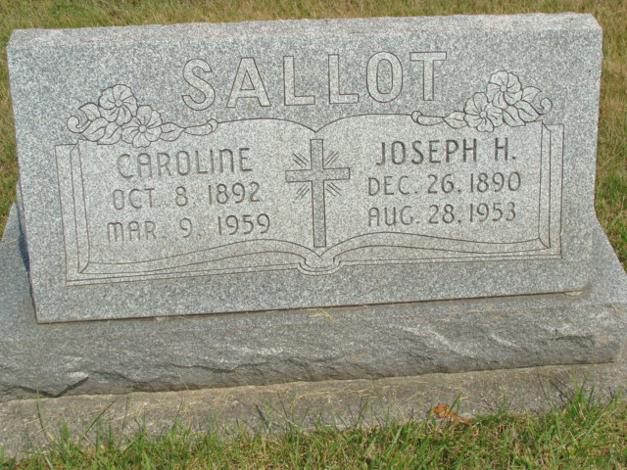
Photo by Alicia Kneuss

Indiana, U.S., Death Certificates, 1899-2017

Name Caroline Sallot
[Caroline Beer]
Gender Female
Race White
Marital Status Widowed
Age 66
Birth Date 8 Oct 1892
Birth Place Monroe Twp.
Death Date 9 Mar 1959
Death Place Berne, Adams, Indiana, USA
Death Registration Date 1959
Father Christian Beer
Mother Sarah Ellenberger
Informant Ermin Beer, brother
Burial 3-11-1959 M.R.E. Cemetery

