Ellis K. Salisbury
November 9, 1925 - September 29, 2008

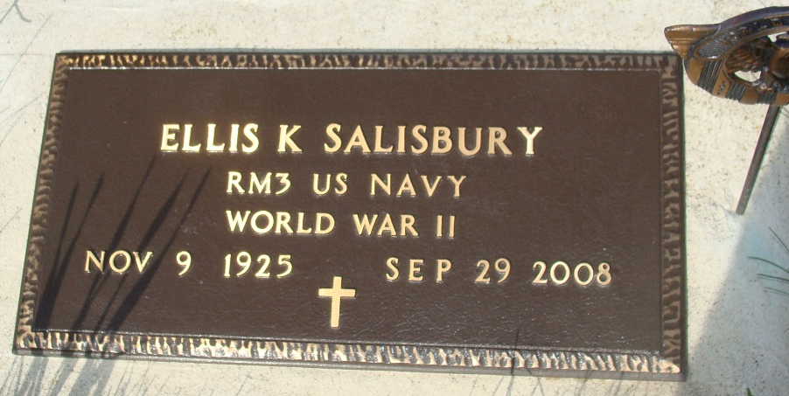
Photo by Alicia Kneuss

Ellis K. Salisbury, 82, of Berne, Indiana passed away at 6:58 a.m. Monday, September 29, 2008 at Parkview Hospital in Fort Wayne, Indiana. Ellis was born on November 9, 1925 in Mecosta, Michigan the son of Arthur and Edith (Turner) Salisbury, both deceased. He married Beverly Haist on March 29, 1964 and she survives.
Ellis was a WW II U.S. Navy veteran. He retired from the Arizona U.S. Forest Service and was a Newscaster and D.J. at radio stations KYCA in Prescott, Arizona and WBRN in Big Rapids, Michigan. Ellis also enjoyed training horses.
Ellis is survived by his wife, Beverly of Berne, Indiana; a son, James (Irena) Salisbury of Las Vegas, Nevada; a daughter, Liz (Andy) Jones of Berne, Indiana; a daughter, Miriam Decker of Berne, Indiana; a son, Gersham (Cari) Salisbury of Prescott, Arizona; a son, Jonathan (Brandy) Salisbury of LaPorte, Indiana; a son, Pastor Douglas (Teri) Salisbury of Columbus, Ohio; a daughter, Karen (Robert) Salazar of Grand Rapids, Michigan; and a son, Terry (Lisa) Salisbury of Big Rapids, Michigan. Other survivors include twenty-four grandchildren and five great-grandchildren. Ellis was preceded in death by two brothers Carl and Beryl Salisbury.
Military graveside services with the Berne American Legion Post 468 will be held at 10:30 a.m. Thursday, October 2, 2008 at the M.R.E. Cemetery of rural Berne, Indiana. Pastor Douglas Salisbury will be officiating. Yager-Kirchhofer Funeral Home in Berne, Indiana is in charge of arrangements.
Preferred memorials are to the Heart Fund or the Adams County Community Foundation.

Yager-Kirchhofer Funeral Home, Adams County, Indiana

