Sherman E. Pyle
March 15, 1916 – October 13, 1991

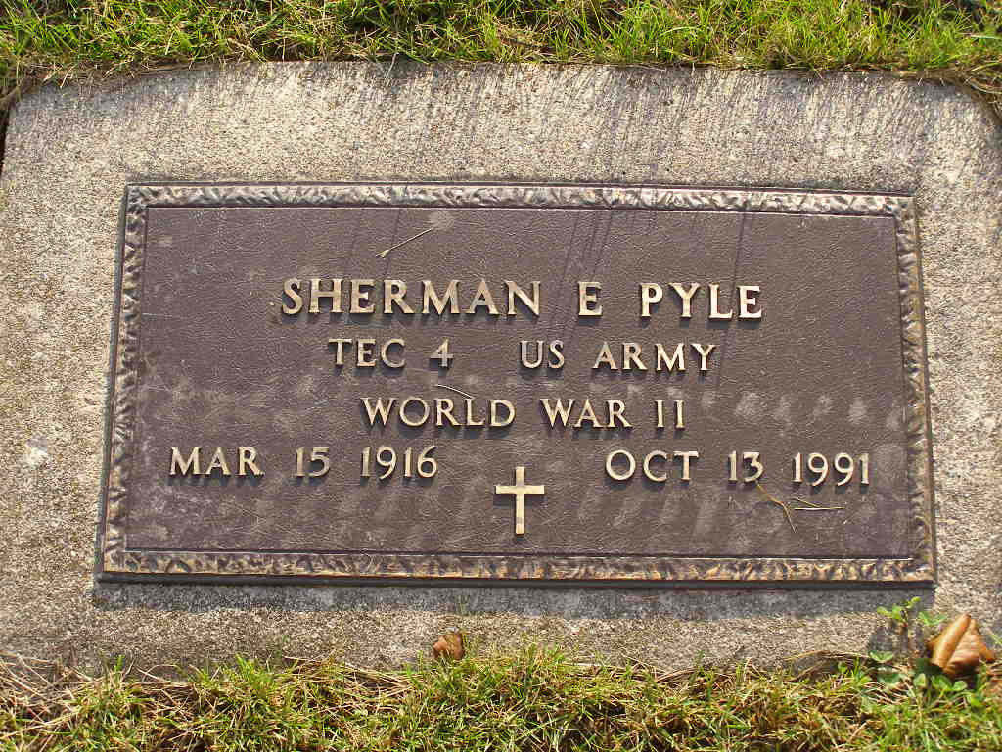
Photo by Shaunda Bedwell Opdycke

Indiana, U.S., Death Certificates, 1899-2017

Name Sherman E Pyle
Gender Male
Race White
Marital Status Married
Age 75
Birth Date 15 Mar 1916
Birth Place Jay County, Indiana
Death Date 13 Oct 1991
Death Place Fort Wayne, Allen, Indiana, USA
Death Registration Date 1991
Father Wilmer Pyle
Mother Ruth Riesen
Spouse Audrey Shepherd Pyle, informant
Burial 10/16/1991 M.R.E. Cemetery

