Charles LeRoy Poorman
October 27, 1896 – September 14, 1971

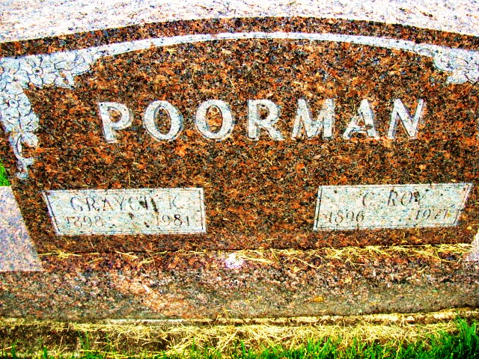
Photo by Alicia Kneuss

C. Roy Poorman Taken By Death Early Today
Rites Here Wednesday for Retired Farmer, 74

Charles LeRoy Poorman (C. Roy Poorman), 74, 276 Parkway, died unexpectedly at 2:45 am today at the Clinic Hospital in Bluffton following a heart attack. He had been in failing health two years.
Mr. and Mrs. Poorman and their son, Max, of New Haven, returned about 10:15 pm Sunday from a weekend trip to Illinois. On their return home Mr. Poorman complained of not feeling well and he was taken to the Clinic Hospital by Yager Ambulance about 39 minutes before he died.
Mr. and Mrs. Poorman moved to 276 Parkway July 3 from their farm in Hartford Township. They moved to the farm, R. R. 1, Geneva, in 1943 from Illinois. He was widely known in Republican politics and was a precinct committeeman for several years.
He was born in Coles County, Illinois, October 27, 1896, a son of Oscar and Florence Moore Poorman. He was married to Grayce Kruger December 25, 1917 at Tuscola, Illinois.
Surviving are the wife; three sons, Max L. Poorman, New Haven; John Henry Poorman, Berne and Lynn W. Poorman, Monroe; four grandchildren; one great-grandchild; three brothers, Vernon Poorman, St. Louis, Mo.; Elmer Poorman, Commerce, Mo., and Hershel Poorman, Alexandria, LA and a sister, Mrs. Cautious (Ruth) Choate, Wichita, Kansas. Two brothers are deceased.
Mr. Poorman was a member of the Humboldt Methodist Church at Humboldt, Illinois.

Date of Burial: Monday, September 15, 1971; Burial: MRE

Berne (IN) Library Heritage Room
MRE Obit Book 1966-1972

