Lavina (Beer) Pickford
March 3, 1891 – December 1, 1930

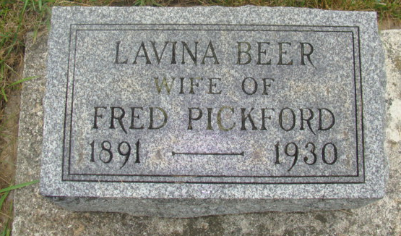
Photo by Alicia Kneuss

Indiana, U.S., Death Certificates, 1899-2017

Name Lavina Pickford
[Lavina Beer]
Gender Female
Race White
Marital Status Married
Age 39y 8m 28d
Birth Date 3 Mar 1891
Birth Place Indiana
Death Date 1 Dec 1930
Death Place Decatur, Adams, Indiana, USA
Death Registration Date 1930
Father C. C. Beer, informant
Mother Sarah Ellenberger
Spouse Fred Pickford
Burial M.R.E. Cemetery 12-4-1930

