Fred Alfred Pickford
March 17, 1893 – November 3, 1951

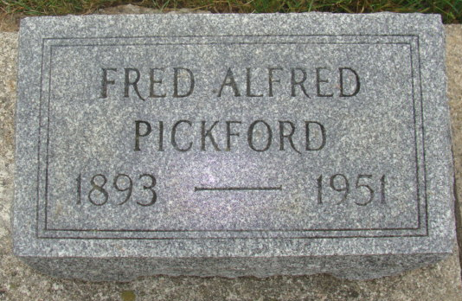
Photo by Alicia Kneuss

Indiana, U.S., Marriages, 1810-2001

Name Fred Pickford
Gender Male
Race White
Age 22
Event Type Marriage Registration (Marriage)
Birth Date 17 Mar 1893
Birth Place Huron, Michigan
Marriage Date 24 Nov 1915
Marriage Place Indiana, United States
Residence Place Adams, Indiana
Father Fred Pickford
Spouse Lavina Beer
Page 49
**

Fred A Pickford from tree Poulson Family Tree

Birth 17 Mar 1893 Huron, Michigan, USA
Marriage 27 Oct 1938 Decatur, Adams, Indiana, USA
Residence 1950 Decatur, Adams, Indiana, USA
Death 3 Nov 1951 Decatur, Adams, Indiana, USA
Father Fred Alfred Pickford (1844-1894)
Mother Christene Diederlion (1855-1899)
Spouse Lavina Beer (1891-1930); Ada Irene Steffen (1913- )
11573 People 17 Records 18 Sources

