Frank Pierce Pickett
July 5, 1887 – August 17, 1953

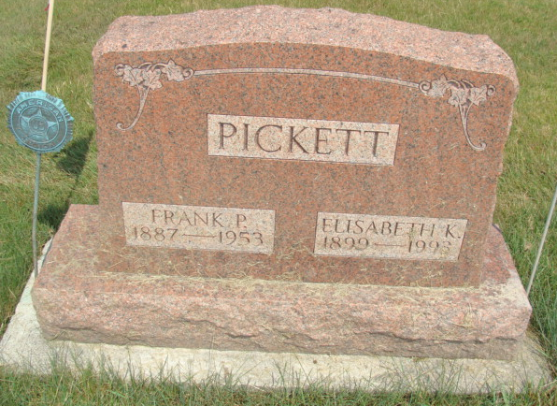
Photo by Alicia Kneuss

Indiana, U.S., Death Certificates, 1899-2017

Name Frank P Pickett
Gender Male
Race White
Marital Status Married
Military WW I
Age 66
Birth Date 5 Jul 1887
Birth Place Geneva, Indiana
Death Date 17 Aug 1953
Death Place Berne, Adams, Indiana, USA
Father William Pickett
Informant Elizabeth Pickett
Burial 8-20-1953 M.R.E.
**

Indiana, U.S., Marriages, 1810-2001

Name Frank Pierce Pickett
Gender Male
Race White
Age 61
Birth Date 5 Jul 1887
Birth Place Berne, Indiana
Marriage Date 11 Sep 1948
Marriage Place Peru, Indiana, United States
Residence Place Berne, Indiana
Father Wm A Pickett
Mother Edna J Rawley
Spouse Elisabeth K Grakos
Page 171

