Elisabeth Katherine (van der Smissen) Pickett
May 13, 1899 – October 18, 1993

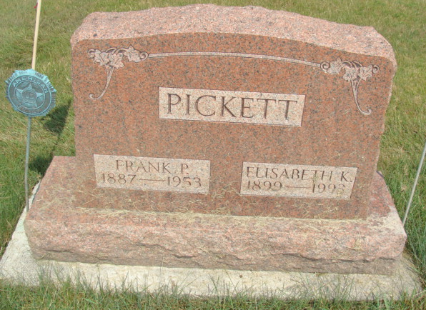
Photo by Alicia Kneuss

Indiana, U.S., Death Certificates, 1899-2017

Name Elisabeth Clemmer
[Elisabeth Smissen]
Gender Female
Race White
Marital Status Widowed
Age 94
Birth Date 13 May 1899
Birth Place Summerfield, Illinois
Death Date 18 Oct 1993
Death Place LaGrange, LaGrange, Indiana, USA
Death Registration Date 1993
Father Carl Vander Smissen
Mother Unavailable Smissen
Informant Richard W. vanderSmissen, son
Burial 10/21/1993 M.R.E. Cemetery
**

Indiana, U.S., Marriage Certificates, 1960-2012

Name Elizabeth Katherine Pickett
Gender Female
Marriage Age 64
Birth Date abt 1900
Birth Place Illinois
Marriage Date 4 Apr 1964
Marriage Place Fort Wayne, Allen, Indiana, USA
Marriage Registration Date 1964
Spouse Bert Alonzo Clemmer
Notes 2 N
Reference Number 1 Bx1452
Reference Number 2 Tr8127
Certificate Number 00051
**

U.S., Social Security Applications and Claims Index, 1936-2007

Name Elisabeth Katherine Clemmer
[Elisabeth K Clemmer]
[Elisabeth Katherine Vandersmisse]
Gender Female
Race White
Birth Date 13 May 1899
Birth Place Summerfield, Illinois
Death Date 18 Oct 1993
Claim Date 9 Apr 1964
Father Carl H Vandersmisse
Mother Elisabeth B Ruth
SSN xxx
Notes Apr 1964: Name Listed As Elisabeth Katherine Clemmer; 09 Apr 1964: Name Listed As Elisabeth K Clemmer

