Sophia Pauley
February 28, 1878 – July 8, 1959

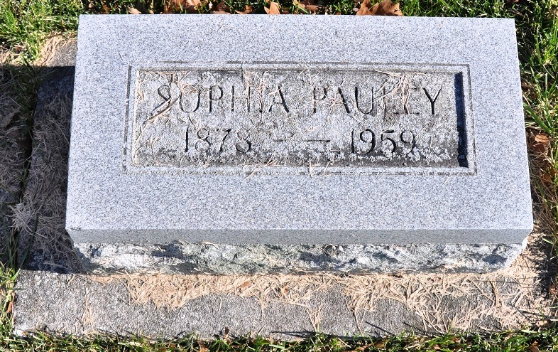
Photo by Deb Curry

Indiana, U.S., Death Certificates, 1899-2017
Name Sophia Pauley
Gender Female
Race White
Marital Status Never Married (Single)
Age 83
Birth Date 28 Feb Abt 1876
Birth Place Nebraska
Death Date 8 Jul 1959
Death Place Fort Wayne, Allen, Indiana, USA
Death Registration Date 1959
Father John Pauley
Mother ?? Ault
Informant June Pauley, sister
Burial 7/11/1959 M.R.E. Cemetery

