Paula H. Pauley
September 3, 1895 – August 31, 1988

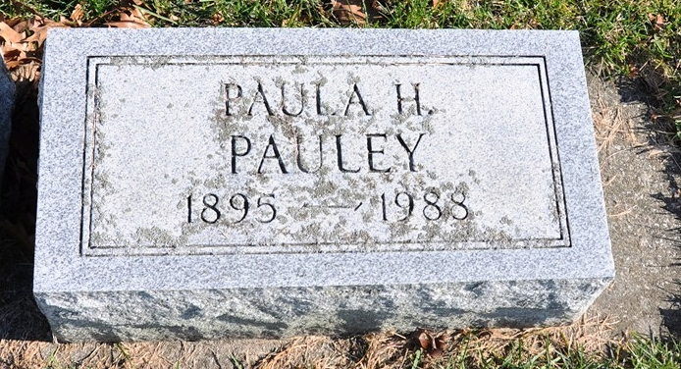
Photo by Deb Curry

Indiana, U.S., Death Certificates, 1899-2017
Name Paula H Pauley
Gender Female
Race White
Marital Status Never Married (Single)
Age 92
Birth Date 3 Sep 1895
Birth Place Sutton, Nebraska
Death Date 29 Aug 1988
Death Place Berne, Adams, Indiana, USA
Death Registration Date 1988
Father John Pauley
Mother Christena Alt
Informant J. Jerome Yager, nephew
Burial 9/2/1988 M.R.E.

