June Pauley
August 16, 1888 – April 20, 1987

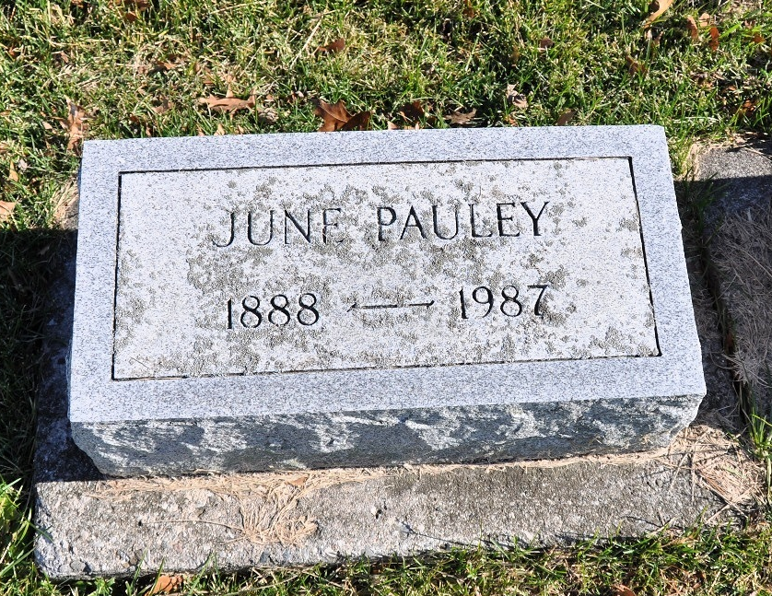
Photo by Deb Curry

Florida, U.S., Death Index, 1877-1998

Name June Pauley
Race White
Age at Death 98
Birth Date 16 Aug 1888
Death Date 20 Apr 1987
Death Place Palm Beach, Florida, United States
**

U.S., Newspapers.com™ Obituary Index, 1800s-current

Name June Pauley
Gender Female
Death Age 98
Birth Date abt 1889
Residence Place Boca Raton, Palm Beach, Florida, USA
Death Date 20 Apr 1987
Obituary Date 21 Apr 1987
Obituary Place Boca Raton, Florida, USA
Newspaper Title Boca Raton News
Siblings Christina P Massinger, Hannah Pauley, Henry Pauley

