Henry J. Pauley
March 27, 1902 – August 9, 1990

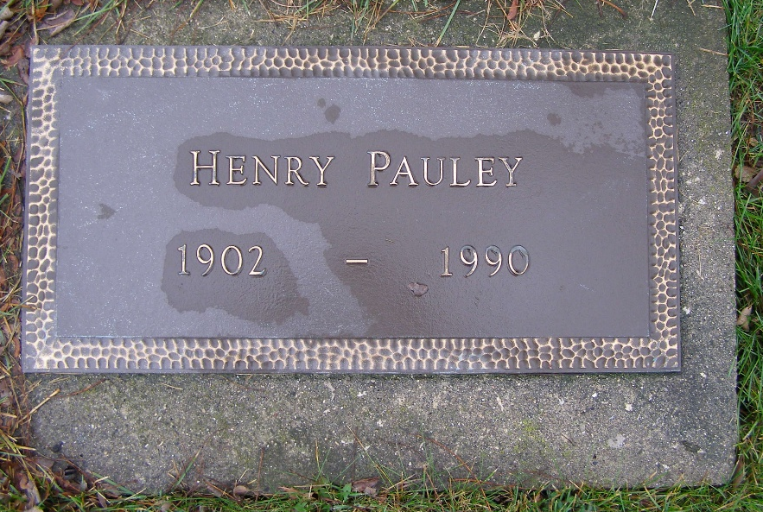
Photo by Shaunda Bedwell Opdycke

U.S., Social Security Death Index, 1935-2014

Name Henry Pauley
Social Security Number xxx
Birth Date 28 Mar 1902
Issue year 1967
Issue State Nebraska
Last Residence 68869, Ravenna, Buffalo, Nebraska, USA
Death Date Aug 1990
**

Nebraska, U.S., Index to Deaths, 1904-2022

Name Henry Pauley
Birth Date 27 Mar 1902
Death Date 9 Aug 1990
Death Place Hall, Nebraska, USA
**

Henry J Pauley from tree Lonny Niederstadt Family Tree

Birth 28 Mar 1902 Nebraska, USA
Residence 1967 Nebraska, USA
Death Aug 1990
Father John Pauley (1855-1945)
Mother Christiana Ault (1856-1945)
134307 People 5 Records 5 Sources

