Steven Edward Paul
October 2, 1957 – October 6, 1975

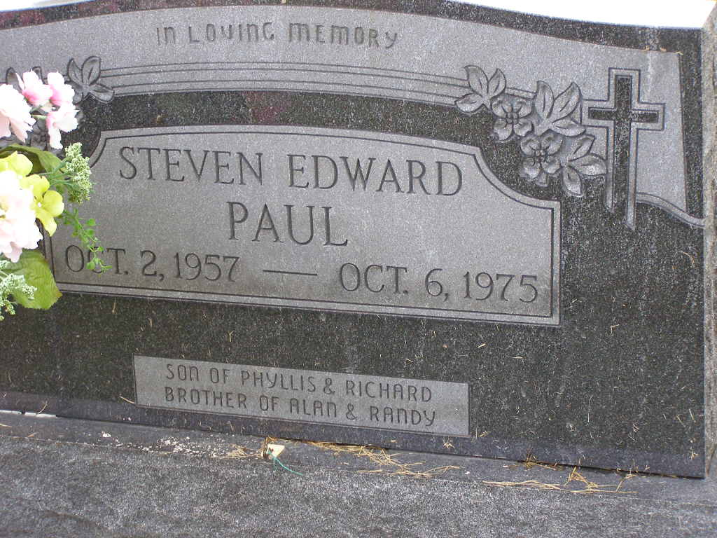
Photo by Shaunda Bedwell Opdycke

Indiana, U.S., Death Certificates, 1899-2017

Name Steven Edward Paul
Gender Male
Race White
Age 18
Birth Date 2 Oct 1957
Birth Place Indiana
Death Date 6 Oct 1975, car accident
Death Place Fort Wayne, Allen, Indiana, USA
Death Registration Date 1975
Father Richard Paul, informant
Mother Phyliss J Schaadt
Burial M.R.E. 10/8/1975

