Inez Kathryn (Sprunger) Patterson
June 9, 1912 – November 29, 1987

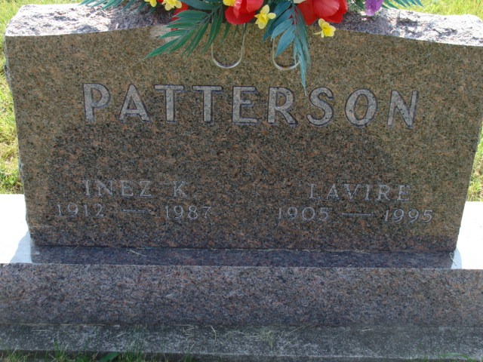
Photo by Alicia Kneuss

Indiana, U.S., Death Certificates, 1899-2017

Name Inez K Patterson
[Inez K Sprunger]
Gender Female
Race White
Marital Status Married
Age 75
Birth Date 9 Jun 1912
Birth Place Indiana
Death Date 29 Nov 1987
Death Place Decatur, Adams, Indiana, USA
Death Registration Date 1987
Father Emil Sprunger
Mother Matilda Hirschy
Spouse Lavire Patterson, informant
Burial M.R.E. 12/2/1987

