Rev. John M. Parr
October 11, 1871 – August 19, 1941

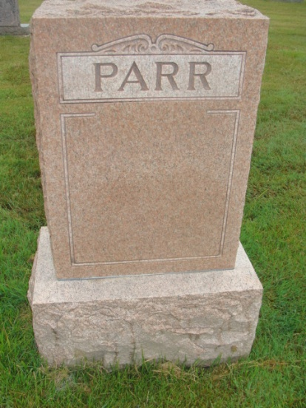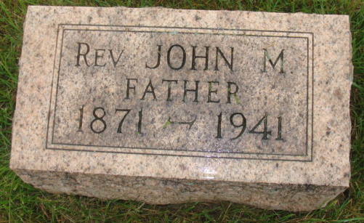
Photos by Alicia Kneuss

Indiana, U.S., Death Certificates, 1899-2017

Name John M Parr
Gender Male
Race White
Marital Status Married
Age 69y 10m 7d
Birth Date 11 Oct 1871
Birth Place Ohio
Death Date 19 Aug 1941
Death Place Rural, Adams, Indiana, USA
Death Registration Date 1941
Father W H Parr
Mother Margaret Jane Foster
Spouse Eva Sims Parr, age 69
Informant Mrs. Eva Parr
Burial M.R.E. 8/21/1941

