Eva (Sims) Parr
February 27, 1882 – April 11, 1961

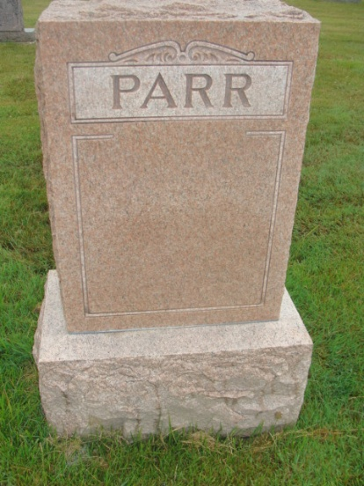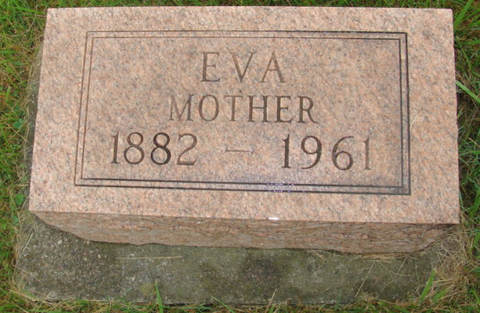
Photos by Alicia Kneuss

Indiana, U.S., Death Certificates, 1899-2017

Name Eva Parr
[Eva Sims]
Gender Female
Race White
Marital Status Widowed
Age 79
Birth Date 27 Feb 1882
Birth Place Ohio
Death Date 18 Apr 1961
Death Place Bluffton, Wells, Indiana, USA
Death Registration Date 1961
Father Ora Sims
Mother Eva Chilcote
Informant Archie H. Parr, son
Burial M.R.E. 4/22/1961

