Dwight Parr
September 15, 1924 – September 15, 1924

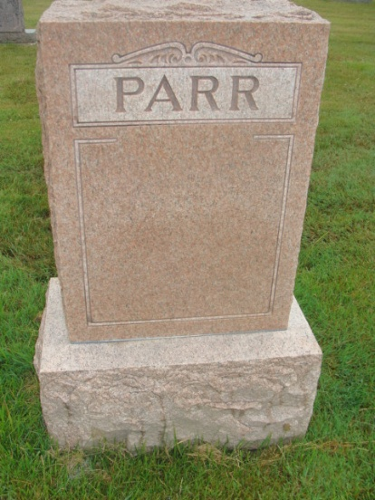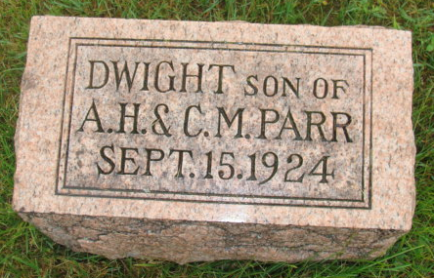
Photos by Alicia Kneuss

Indiana, U.S., Death Certificates, 1899-2017
Name Dwight Parr (indexed as Pars)
Gender Male
Race White
Age 7 hours
Birth Date 15 Sep 1924
Birth Place Berne Indiana
Death Date 15 Sep 1924
Death Place Berea, Adams, Indiana, USA
Death Registration Date 1924
Father Archie Parr
Mother Carrol Liddy
Informant ?? Baumgardner
Burial MRE 9/15/1924

