Carol M. (Liddy) Parr
January 14, 1903 – May 27, 1986

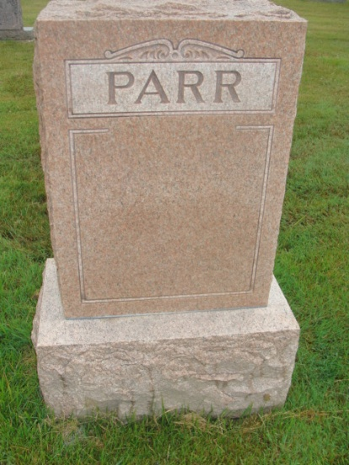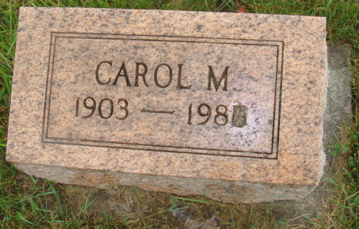
Photos by Alicia Kneuss

Indiana, U.S., Death Certificates, 1899-2017
Name Carol M Parr (indexed as Pau)
[Carol M Liddy]
Gender Female
Race White
Marital Status Widowed
Age 83
Birth Date 14 Jan 1903
Birth Place Indiana
Death Date 27 May 1986
Death Place Berne, Adams, Indiana, USA
Death Registration Date 1986
Father Joe L Liddy
Mother Atlanta Hill
Informant Betty Bebout, daughter
Burial M.R.E. 5/30/1986

