Archie Howard Parr Sr.
January 1, 1902 – September 3, 1981

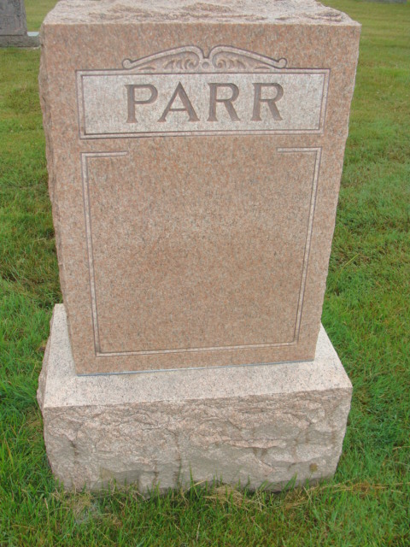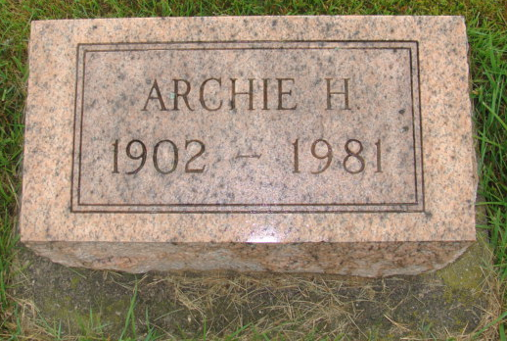
Photos by Alicia Kneuss

Indiana, U.S., Death Certificates, 1899-2017
Name Archie Parr Sr
Gender Male
Race White
Marital Status Married
Age 79
Birth Date 1 Jan 1902
Birth Place Indiana
Death Date 3 Sep 1981
Death Place Bluffton, Wells, Indiana, USA
Death Registration Date 1981
Father John M Parr
Mother Eva Sims
Spouse Carol Liddy Parr
Informant Caror Parr
Burial M.R.E. 9/5/1981

