Charles Fredrick Nyffeler, Sr.
June 3, 1854 – February 5, 1936

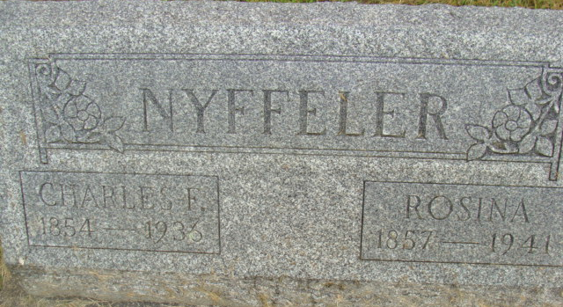
Photo by Alicia Kneuss

Handwritten date: Thursday, February 6, 1936
DEATH TAKES FATHER OF DR. EDWIN NYFFELER
Charles F. Nyffeler, 81 dies Wednesday Night Near Monroe - Funeral Here Saturday P.M.
Charles Fredrick Nyffeler, aged 81, well known retired farmer and father of Dr. Edwin Nyffeler of this place, died at 6:30 o'clock Wednesday evening at his home two miles west and one mile north of Monroe. Mr. Nyffeler ailed for 1 year and 9 months suffering from complications of old age. He spent six months at the home of Dr. Nyffeler here in town but returned to his farm home some time ago.
Mr. Nyffeler was born in Neuenstadt, Canton Bern, Switzerland, June 3, 1854, bringing his age to 81 years, 8 months and 2 days. He was a son of Ulrich and Marie Scutter Nyffeler. He grew to manhood in Switzerland and on June 7, 1880 he was united in marriage to Rosina Rufenuer. The wedding took place at Bluemenstein, Switzerland. The couple came to America in 1887 and settled in Adams County, living here ever since.
Surviving is the widow, and the following children: Charles and Oswald Nyffeler of near Decatur; Otto and Louis Nyffeler of Ft. Wayne: Mrs. Rosa Bracht of Fort Wayne; Mrs. Leah Speicher, Geneva; Dr. Edwin Nyffeler, Berne and William Nyffeler of Indianapolis. Two sisters survive in Switzerland. Sixteen grandchildren and three great grandchildren also survive. The parents and one infant son preceded him.
Mr. Nyffeler was a member of the Cross Reformed Church here.
The funeral will be held Saturday afternoon at 1:15 o'clock at the home near Monroe and at 2 o'clock at the local Cross Reformed Church, Rev. Calvin Schmidt officiating. Burial will be in the M. R. E. Cemetery.

Adams County Historical Museum, Adams County, Indiana
1936 Scrapbook
**
Indiana, U.S., Death Certificates, 1899-2017
Name Charles Fredrick Nyffeler Sr
Gender Male
Race White
Marital Status Married
Age 81
Birth Date 3 Jun 1854
Birth Place Switzerland
Death Date 5 Feb 1936
Death Place Washington, Adams, Indiana, USA
Death Registration Date 1936
Father Ulrick Nyffeler
Mother Mary Sutter
Spouse Rosina
Informant Mrs. Rosina Nyffeler; Decatur, Indiana
Burial February 8, 1936; MRE Cemetery

