Jacob Nuszbaum
December 25, 1836 – January 3, 1902

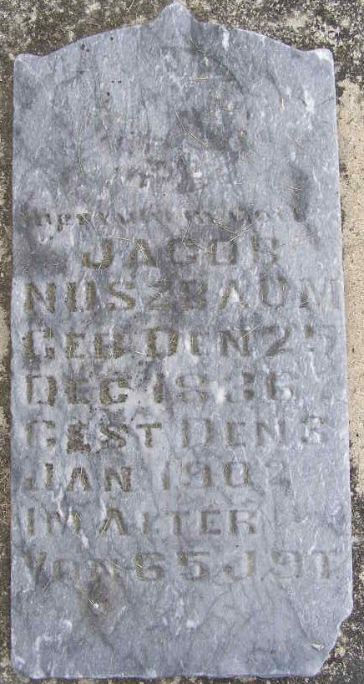
Photo by Shaunda Bedwell

Jacob Nussbaum
in the Indiana, U.S., Death Certificates, 1899-2017
Name Jacob Nussbaum
Gender Male
Race White
Marital Status Married
Age 65
Birth Date 25 Dec 1836
Birth Place Switzerland, Europe
Death Date 3 Jan 1902
Death Place Wabash, Adams, Indiana, USA
Death Registration Date 1902
Father Jacob Nussbaum
Mother Mary Geiger
Informant Jephtha Sprunger; Berne, Indiana
Burial January 5, 1902; MRE Cemetery

