Anna (Sprunger) Nuszbaum
April 9, 1829 – November 17, 1902

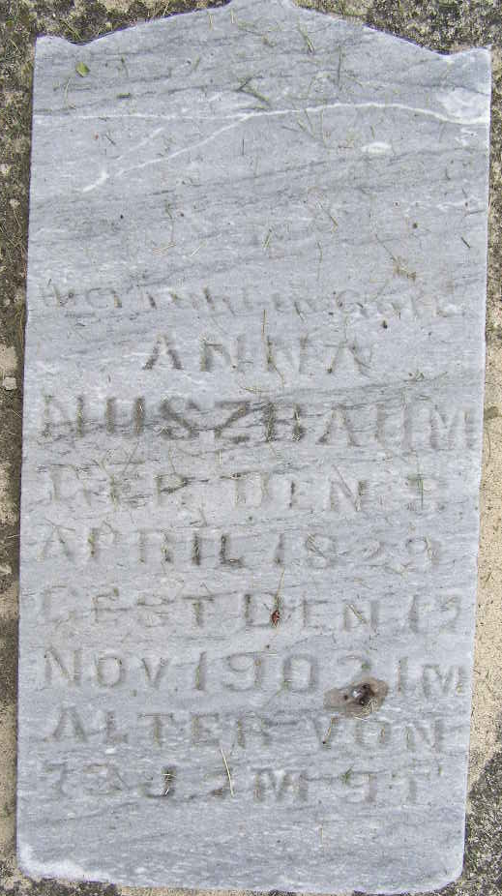
Photo by Shaunda Bedwell Opdycke

Anna Nussbaum
in the Indiana, U.S., Death Certificates, 1899-2017
Name Anna Nussbaum
[Anna Sprunger]
Gender Female
Race White
Marital Status Widow
Age 73
Birth Date 9 Apr 1829
Birth Place Switz
Death Date 17 Nov 1902
Death Place Wabash, Adams, Indiana, USA
Death Registration Date 1902
Father Christian Sprunger
Mother Anna Lehman
Informant Jeff Sprunger; Berne, Indiana
Burial November 19, 1902; MRE Cemetery

