Willis Glenn Nussbaum
October 8, 1935 -

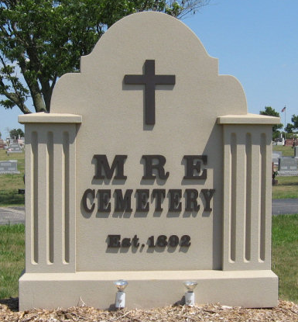
Photo by Tombstoner & Family

Willis Glenn Nussbaum
in the Indiana, U.S., Birth Certificates, 1907-1944
Name Willis Glenn Nussbaum
Gender Male
Birth Date 8 Oct 1935
Birth Place Monroe, Adams, Indiana, USA
Father Rufus Nussbaum; age 38
Mother Ida Rich; age 37; 6th child, all living
Certificate Number 39649
Roll number 40474_357210
Volume Range 78 - 82

