Virginia Faye (Mitchel) Nussbaum
July 17, 1935 -

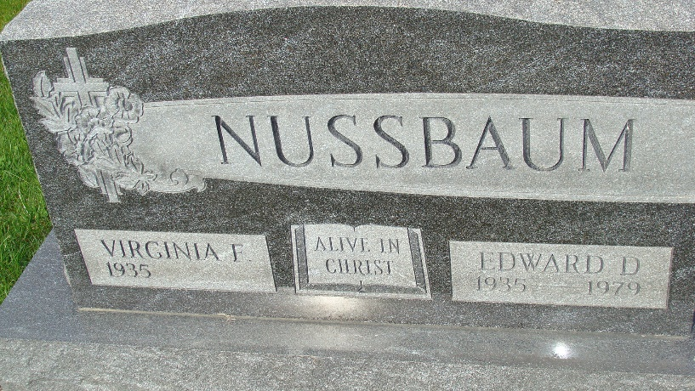
Photo by Alicia Kneuss

Virginia Faye Mitchel
in the Indiana, U.S., Birth Certificates, 1907-1944
Name Virginia Faye Mitchel
Gender Female
Birth Date 17 Jul 1935
Birth Place Decatur, Adams, Indiana, USA
Father Russel Mitchel; age 24
Mother Delores Longenberger; age 20; 1st child
Certificate Number 25311
Roll number 40474_357204
Volume Range 49 - 53

