Maxine E. (Meyer) Nussbaum
August 1, 1923 – July 24, 2020

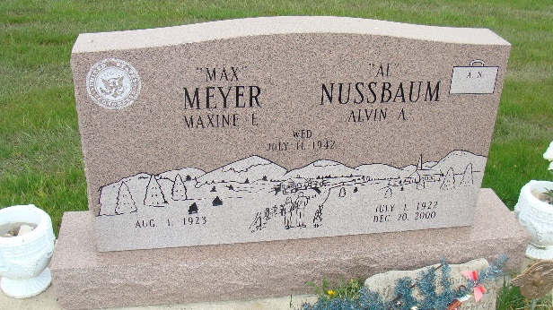
Photos by Alicia Kneuss

MAXINE E. MEYER NUSSBAUM died at her home July 24, 2020. The youngest child of John A. and Lena K. Meyer, she was born August 1, 1923, in Andrews, Indiana. At age 13, she moved with her family to the farm two miles west of Berne. FDR’s rural electrification made her a life-long Democrat. She married Alvin A. Nussbaum of Monroe in 1942. Working at the Berne Kroger store, she knew everyone in town. She and Al moved to Muncie in 1953. For 48 years there, she was active with First Presbyterian Church, Church Women United, the World Council of Churches, and other worthy organizations. When her kids flew the nest, she devoted her energies as a staff member for Congressman Phil Sharp, driving the Mobile Office and hearing constituent concerns. She loved her life in the legislative and political arena for 20 years. She especially loved the campaigns and hog roasts in the district, with occasional trips to Washington DC. She hated having to retire in 1995, when the Congressman did; but she would not work for his successor from the other party.
In 2000, health concerns led her and Al to move to Swiss Village in Berne. She was a member of Cross United Church of Christ, where she enjoyed singing with the ensemble and performing as church organist. She loved activities with her nephews, nieces, bonus daughters, and their families.
Maxine was predeceased by her husband, Al; siblings and spouses, Margaret (Leonard “Ben”) Beitler, Matilda (Wilbur) Leatherman, and Raymond “Jake” (Mildred) Meyer; Al’s brothers and their spouses, Leo (Janet), Elmer (Ruth Ellen), Milo (Violet), Victor, Reuben (Estella), and Carl (Justine); son-in-law, Charles A. Nietch; grandson, David J. Nietch; and Sylvia Russell.
Max is survived by her children Ronda Nietch, Niles MI; (Nira) Jo Nussbaum, Vancouver BC Canada; Lenell Nussbaum (Peter Skartvedt), Seattle WA; and Jon K. (Kelly) Nussbaum, Temecula CA; grandchildren Annamarie (Mike) Waterman, Marcellus MI; Jennifer (Scott) Betzner, Indianapolis IN; Nicholas Skartvedt (Lyndsay Watson), Vancouver BC; Noah Skartvedt (Alexandra Hernandez), Seattle WA; Kiley (Jerry) Lan, Temecula, CA; Shelby Buffington, Tustin, CA; Ethan Nussbaum, Radcliffe, KY; Julianne Nussbaum, Temecula, CA; great-grandchildren Kristina (Phillip) Hedges, Indianapolis; Riley Waterman and Spencer Waterman, Marcellus; and Tiffani Betzner, Indianapolis; her bonus daughters, Susan Yoder, Jenny Yager, and Renee Captain, Berne; and many nieces and nephews.
Maxine was a fierce advocate for what she considered right. She always loved a party and fancy cakes. She found joy in music (major keys, please), flowers, and, as everyone knew, anything pink.
Visitation Friday, July 31, 2020, from 4-8 p.m., at Zwick & Jahn Funeral Home, Yager-Kirchhofer Chapel located at 365 W. Main St., Berne. Funeral will be held at Zwick & Jahn Funeral Home, Yager-Kirchhofer Chapel at 10:30 a.m. on Saturday, August 1, 2020, with Pastor Timothy Price officiating. Since it is her 97th birthday, there will be pink balloons and the family requests that visitors wear something pink in Maxine's honor! Burial will follow at M.R.E. Cemetery of rural Berne. Due to the Covid-19 guidelines facemasks are asked to be worn during your visit.
In lieu of flowers, memorials may be made to Cross United Church of Christ, Berne, or any effort to defeat the current occupant of the White House.

Zwick & Jahn Funeral Homes, Adams County, Indiana

