Kenyon C. Nussbaum
September 3, 1922 – January 9, 2006
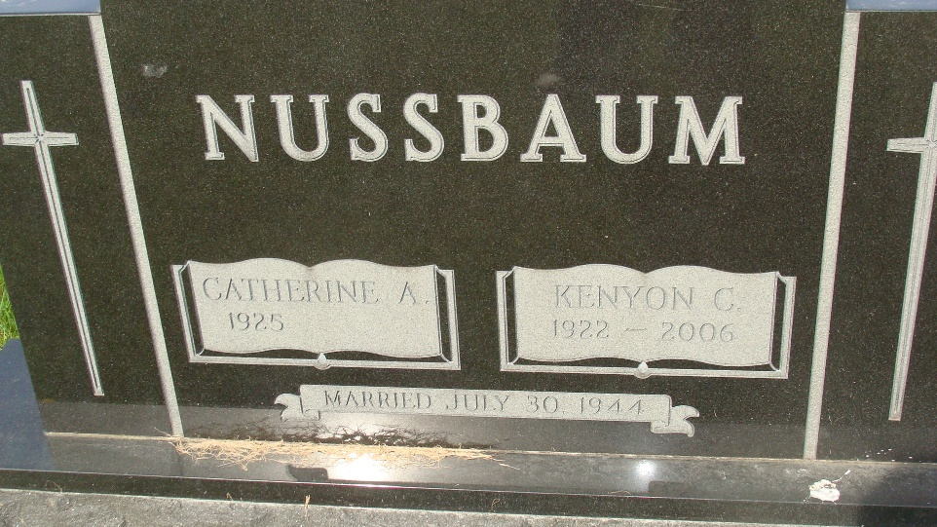
Photo by Alicia Kneuss

KENYON C. NUSSBAUM, 83, of Fort Wayne, formerly of Berne, died Monday, Jan. 9, 2006 at Parkview Hospital. He was born September 3, 1922 in Adams County and married Katie (Wulliman) on July 30, 1945 in Berne. He was the son of Edwin Nussbaum and Ora Baumgartner. He owned Berne Apparel Co. (former Berco), was a member of First Mennonite, Berne, Mennonite Men’s Chorus. He was a former Sunday School teacher and he served in the United States Air Force Medical Corp in Burma and India. His hobbies included fishing.
Surviving are his wife, Katie; one son, Ron (Liz) Nussbaum, Fort Wayne; one daughter, Susan (John) Rayls, San Antonio, Texas; seven grandchildren, four great-grandchildren; a sister, jean (Vernon) Neuenschwander, Berne; and a brother, Howard (Eloise) Nussbaum, Monroe. Service is 10:30 a.m. at First Mennonite Church, Berne with Rev. Ray Kein and Rev. Harold Nussbaum officiating.
Visitation is Thursday, 2 to 6 p.m. at Yager-Kirchhofer Funeral home, Berne, and Friday one hour prior to church service. Memorials to First Mennonite Church Missions and Swiss Village.

Journal Gazette, The (Allen County, Indiana)
Wednesday, January 11, 2006
**
Kenyon C. Nussbaum, 83, Fort Wayne, a former Berne resident and former owner of Berne Apparel Company, died Monday at Parkview Hospital in Fort Wayne.
Born on Sept. 3, 1922, in Adams County to Edwin and Ora (Baumgartner) Nussbaum, he married Katie Wulliman on July 30, 1945. She survives. Other survivors include a son, a daughter, a sister, a brother, seven grandchildren and four great-grandchildren.
Services are Friday at First Mennonite Church, Berne, with the Revs. Ray Keim and Harold Nussbaum officiating. Burial will be in M.R.E. Cemetery. Visitation is today from 2 to 8 p.m. at Yager-Kirchhofer Funeral Home in Berne and one hour prior to services on Friday at the church. Memorials may be sent to the First Mennonite Church Missions or Swiss Village.
Commercial Review, The (Jay County, Indiana)
Friday, January 13, 2006
**

Indiana, Death Certificates, 1899-2011

Name Kenyon C Nussbaum
Gender Male
Race White
Marital Status Married
Age 83
Birth Date 3 Sep 1922
Birth Place Adams County
Death Date 9 Jan 2006
Death Place Fort Wayne, Allen, Indiana, USA
Death Registration Date 2006
Father Edwin Nussbaum
Mother Ora Baumgartner
Spouse Katie Wulliman Nussbaum, informant
Burial MRE 1/13/2006

