Jack D. Nussbaum
February 27, 1933 – September 5, 1984

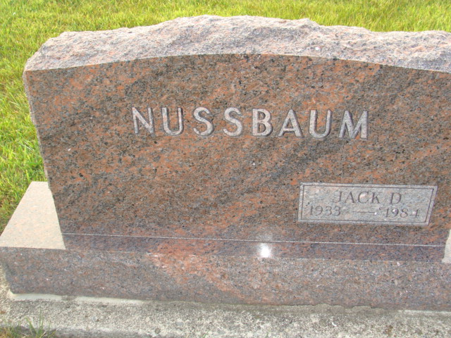
Photo by Alicia Kneuss

Rites Saturday for North Teacher Jack Nussbaum

Funeral service for Jack D. Nussbaum, 51, of 2102 Home, social studies teacher and athletic events ticket manager at Columbus North High School, will be conducted by the Rev. jerry Day and the Rev. David Marvin at 11 a.m. Saturday at Berean Bible Church. Calling hours will be from 1 to 8 p.m. Friday at Reed and Jewell Funeral Home and at the church Saturday from 10 a.m. until service time.
A second service will be conducted at 2 p.m. Sunday at First Mennonite Church at Berne with calling hours at Yager Funeral Home in Berne from 7 to 9 p.m. Saturday. Burial will be at the M.R.E. Cemetery there.
Memorials may be made to the missionary fund at Berean Bible Church where Nussbaum was a member.
He died at 8:20 a.m. Wednesday at Methodist Hospital in Indianapolis after being in failing health the past year and seriously ill the past two weeks.
He had been a teacher in the high school here since 1956, and was a member of Columbus Educators Association the Parks and Recreation Department band.
He was born Feb 27, 1933, in Berne, the son of Benhart and Ada Liechty Nussbaum of Berne. He married Barbara J. Klopfenstein March 30, 1957, and she survives.
Also surviving are five sons, Andrew and Philip Nussbaum, of Wheaton, Ill., Timothey Nussbaum of Indianapolis and Matthew and Thomas Nussbaum of Columbus; one brother, Loren Nussbaum of Austin, Texas, and one sister, Mary Ellen Nussbaum of Berne.

The Republic, Delaware County, Indiana
Thursday, September 6, 1984

