Irene Sprunger Nussbaum
July 26, 1914 – July 26, 1914

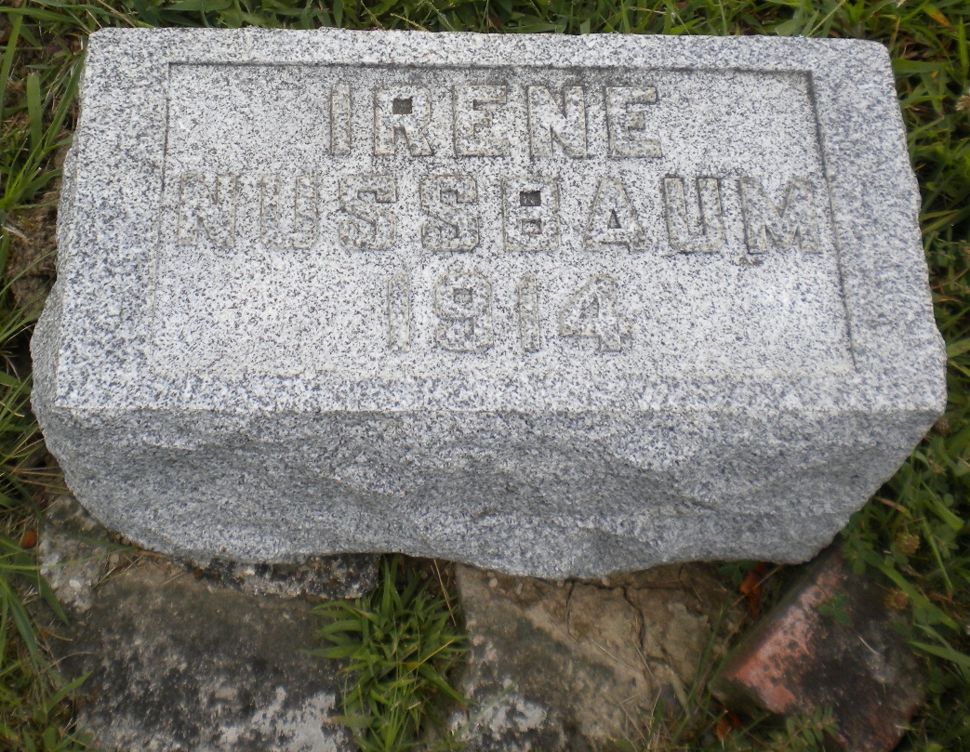
Photo by DSON1492

Indiana, Death Certificates, 1899-2011

Name Juena Sprunger Neusbaum (looks like Irena)
Age 0, premature birth
Birth Date 26 Jul 1914
Birth Place Adams County
Death Date 26 Jul 1914
Death Place Berne, Adams, Indiana, USA
Death Registration Date 1910-1919
Father Wilbur Neusbaum, informant
Mother Lila Sprunger
Burial MRE 7-26-1914

